**GAM 350 Engagement Arc - Apathetic Apothecary**

*Chamomile Grove*

**Engagement Arc and Scenario Flow:**

**Setup:**

Introduce the player to farming and begin the narrative with short dialogue.

**Hook:**

Introduce crafting, showing players that they can mix and craft things out of what they have grown.

**Development:**

Farm plants in order to harvest ingredients that can be used in crafting

Use those ingredients to craft potions that can be traded for rewards via the ticket and shop systems.

Use potions obtained through crafting and shop to solve puzzles to progress the game.

Use seeds obtained from puzzles to continue farming.

Repeat a number of times as the narrative unfolds.

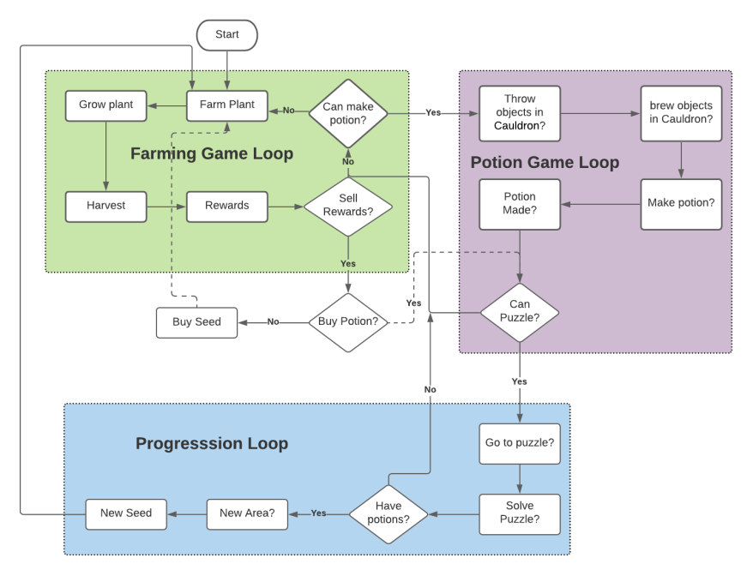

*Full Gameplay Loop*

**Turn:**

The player will encounter a puzzle that tests their knowledge of all the mechanics they have encountered so far, forcing them to think in a new context and apply what they have learned up to that point.

**Resolution:**

The player will solve a number of easy puzzles in succession allowing them to relax after the difficult puzzle they just solved